**LAB # 02**

**Task # 01:** Create a class student which contains the basic data about the student that takes the basic student data and displays it by using display method. An option of update is being provided to the user if he/she want to update the data, the required data being updated.

**Solution:** public static void main(String[] args) {

Scanner input=new Scanner(System.in);

student cs=new student();

char r;

do {

System.out.println("WHICH PROCESS DO YOU WANT TO PERFORM ---\n1) DISPLAY\n2) UPDATE");

System.out.print("Select from above (1) OR (2) : ");

int res=input.nextInt();

switch(res){

case 1:

cs.Display();

break;

case 2:

cs.Update();

System.out.println("-----------------------------");

System.out.println("---- UPDATED -----");

System.out.println("-----------------------------");

cs.Display();

break;

default:

System.out.println("---------------------------------");

System.out.println(" INVALID ENTRY --- ---- -- -- ");

System.out.println("---------------------------------");

break; }

System.out.print("DO YOU WANT TO PERFORM AGAIN (y | n): ");

r=input.next().charAt(0);

} while (r=='y'); }

**STUDENT CLASS:**

public class student {

Scanner cs=new Scanner(System.in);

String name="AHSAN";

int age=18;

char gender='M';

String enr_no="02-131212-049";

int sem=2;

void Update(){

System.out.print("ENTER YOUR NAME: ");

name=cs.nextLine();

System.out.print("ENTER YOUR AGE: ");

age= cs.nextInt();

System.out.print("ENTER YOUR GENDER (M)0R(F) : ");

gender=cs.next().charAt(0);

System.out.print("ENTER YOUR ENROLLMENT NO: ");

enr_no=cs.next();

System.out.print("ENTER YOUR SEMESTER: ");

sem= cs.nextInt(); }

void Display(){

System.out.println("NAME = "+ name);

System.out.println("AGE = "+age);

System.out.println("GENDER = "+gender);

System.out.println("ENROLLMENT NO = "+enr_no);

System.out.println("SEMESTER = "+sem); }}

**Output:** 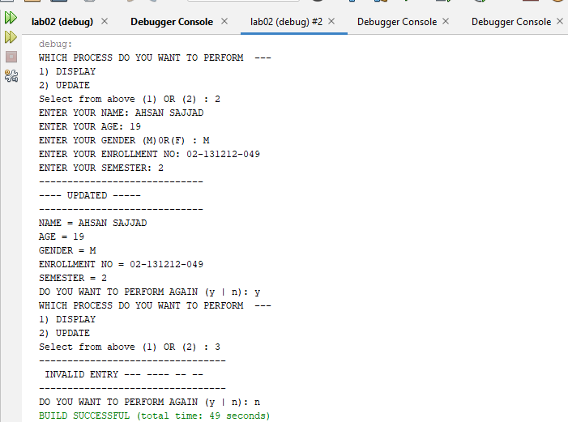

**Task # 02:**  Create a class “computer” which contains specifications of computer, the program shall ask the user does he/she wants to open the system, if the user press “yes” then the system starts shows the initial loading and then displays the basic configuration of a system (by calling the method of display () , update option is being provided by the user, values of the specified items are being updated once user decides to update that item.

**Solution:**

public static void main(String[] args) {

Scanner input=new Scanner(System.in);

computer cs=new computer();

System.out.println("you want to open the system ------- ");

System.out.println("(1) YES \n(2) NO");

System.out.print("SELECT FROM ABOVE : ");

int res=input.nextInt();

switch(res) {

case 1:

cs.Display();

System.out.println("you want to update \n1) YES \n2) NO");

System.out.print("SELECT FROM ABOVE : ");

int re=input.nextInt();

if (re==1) {

cs.Update();

System.out.println("--------------------------------");

System.out.println("----- UPDATED ------");

System.out.println("--------------------------------");

cs.Display();

}else if(re==2){

System.out.println("you don't want to update ---- ");}

else {

System.out.println("--------------------------------");

System.out.println("INVALID ENTRY -------- ");

System.out.println("--------------------------------");}

break;

case 2:

System.out.println("--------------------------------");

System.out.println("YOU DON'T WANT TO OPEN THE SYSTEM -----");

System.out.println("--------------------------------");

break;

default:

System.out.println("--------------------------------");

System.out.println("INVALID ENTRY-------");

System.out.println("--------------------------------"); break; } }

**COMPUTER CLASS:**

public class computer {

Scanner input=new Scanner(System.in);

String ram="4GB";

String rom="240GB";

int gen=4;

String core="i5";

void Update(){

System.out.println("-----------------------------------------");

System.out.print("enter the RAM of computer: ");

ram=input.nextLine();

System.out.print("enter the ROM of computer: ");

rom=input.nextLine();

System.out.print("enter the GENERATION of computer: ");

gen=input.nextInt();

System.out.print("enter the CORE of computer: ");

core=input.next();

System.out.println("----------------------------------------");

}

void Display(){

System.out.println("------------------------------------");

System.out.println(" --= SPECIFICATION OF MY COMPUTER =-- ");

System.out.println("\nRAM = "+ram);

System.out.println("ROM = "+rom);

System.out.println("GENERATION = "+gen);

System.out.println("CORE = "+core);

System.out.println("------------------------------------");

}}

**Output:**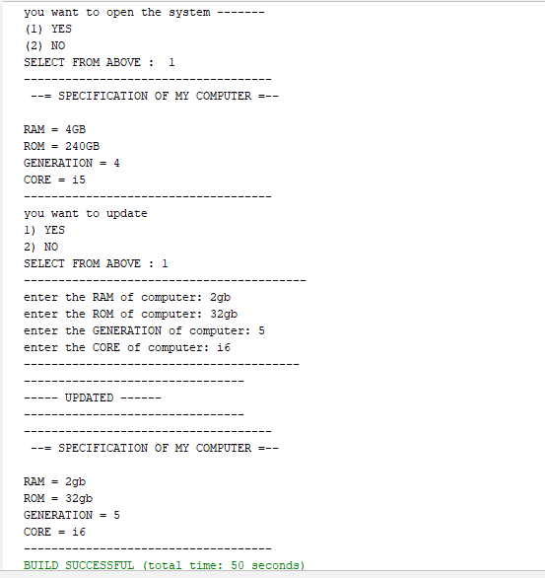

**Task # 03:**  Create a class of Employee which contains basic information about an employee, employee name, father’s name and salary etc are being displayed by the display method and the salary of employees or the designation of the employees are being set/updated as per need.

**Solution:** employee myclass=new employee();

Scanner input=new Scanner(System.in);

char re;

do { System.out.println(" --------- Employee Information ---------");

System.out.println("1) Display\n2) Update -- Salary , Designation -- ");

System.out.print("Select from above :");

int res=input.nextInt();

switch(res){ case 1:

myclass.Display();

break;

case 2:

myclass.Update();

System.out.println("---------------------------------");

System.out.println("------- UPDATED -------");

System.out.println("---------------------------------");

myclass.Display();

break; default:

System.out.println("---------------------------------");

System.out.println("------- INVALID ENTRY -------");

System.out.println("---------------------------------");

break;}

System.out.print("Do you want to update again: ");

re=input.next().charAt(0);

} while (re=='y'||re=='Y');

**EMPLOYEE CLASS**

public class employee {

Scanner input=new Scanner(System.in);

String name="Ahsan";

String f_name="Abdul Haq";

int salary = 50000;

String des="director";

void Display(){

System.out.println("--------------------------");

System.out.println("NAME = "+ name);

System.out.println("FATHER NAME = "+ f_name);

System.out.println("SALARY = "+ salary);

System.out.println("DESIGNATION = "+ des);

System.out.println("--------------------------");}

void Update(){

System.out.println("--------------------------");

System.out.print("UPDATE YOUR SALARY : ");

salary= input.nextInt();

System.out.print("UPDATE YOUR DESIGNATION : ");

des=input.next();

System.out.println("--------------------------");}}

**Output:**

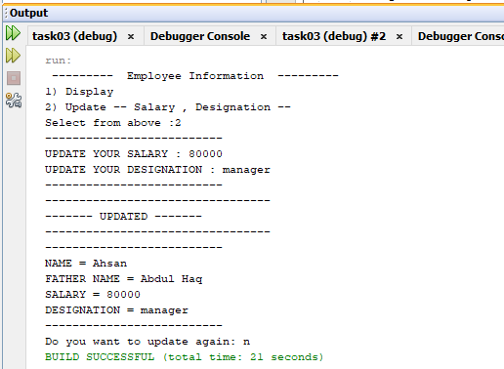

**Task # 04:** Create a class of Automobile which contains specifications of a car, check whether the car is in - ON/start state if not them asks the user if he/she want to start the car, If the car is already in start state then first display the current status of the car which includes the horse power, color, made, engine type etc. providing an option to the user if he/she wants to update any of the mentioned part from the car, if user selects “YES” then it is updated according to the need of the user, else the program will be ended.

**Solution:**

public static void main(String[] args) {

Scanner input = new Scanner(System.in);

Automobile cs=new Automobile();

System.out.println("the current state of car ");

System.out.println("1) ON \n2) OFF");

System.out.print("Select from above: ");

int re=input.nextInt();

switch(re){ case 1:

System.out.println("---- CURRENT sTATUS OF cAR -------");

cs.Display();

System.out.print("Do you want to update any part(y/n): ");

char res=input.next().toLowerCase().charAt(0);

if (res=='y') {

System.out.print("Which part Do you want to update: ");

System.out.println("1) horse power \n2) colour \n3) made\n4) Engine type ");

System.out.print("Select from above: ");

int rep=input.nextInt();

switch (rep){

case 1:

cs.ChangeHp();

System.out.println("------------------------------------");

System.out.println("-----UPDATED ---------");

System.out.println("------------------------------------");

cs.Display();

break;

case 2:

cs.ChangeColour(); System.out.println("------------------------------------");

System.out.println("-----UPDATED ---------");

System.out.println("------------------------------------");

cs.Display();

break;

case 3:

cs.Changemade();

System.out.println("------------------------------------");

System.out.println("-----UPDATED ---------");

System.out.println("------------------------------------");

cs.Display();

break;

case 4:

cs.ChangeEngine();

System.out.println("------------------------------------");

System.out.println("-----UPDATED ---------");

System.out.println("------------------------------------");

cs.Display();

break;

default:

System.out.println("------------------------------------");

System.out.println("----- INVALID ENTRY ---------");

System.out.println("------------------------------------");

cs.Display();

break; }

}else {

System.out.println("----PROGRAM TERMINATED----");}

break;

case 2:

System.out.print("Do you want to start the car(y/n): ");

char r=input.next().toLowerCase().charAt(0);

if (r=='y') {

System.out.println("---- CURRENT sTATUS OF cAR -------");

cs.Display();

System.out.print("Do you want to update any part(y/n): ");

char repl=input.next().toLowerCase().charAt(0);

if (repl=='y') {

System.out.print("Which part Do you want to update: ");

System.out.println("1) horse power \n2) colour \n3) made\n4) Engine type ");

System.out.print("Select from above: ");

int rep=input.nextInt();

switch (rep){ case 1:

cs.ChangeHp();

System.out.println("------------------------------------");

System.out.println("-----UPDATED ---------");

System.out.println("------------------------------------");

cs.Display();

break;

case 2:

cs.ChangeColour();

System.out.println("------------------------------------");

System.out.println("-----UPDATED ---------");

System.out.println("------------------------------------");

cs.Display();

break;

case 3:

cs.Changemade();

System.out.println("------------------------------------");

System.out.println("-----UPDATED ---------");

System.out.println("------------------------------------");

cs.Display();

break;

case 4:

cs.ChangeEngine();

System.out.println("------------------------------------");

System.out.println("-----UPDATED ---------");

System.out.println("------------------------------------");

cs.Display();

break;

default:

System.out.println("------------------------------------");

System.out.println("----- INVALID ENTRY ---------");

System.out.println("------------------------------------");

cs.Display();

break; }

}else {

System.out.println("----PROGRAM TERMINATED----"); }}

else {

System.out.println("----PROGRAM TERMINATED----");} break;

default:

System.out.println("------------------------------------");

System.out.println("----- INVALID ENTRY ---------");

System.out.println("------------------------------------"); break;}

**AUTOMOBILE CLASS:**

public class Automobile {

Scanner input = new Scanner(System.in);

String hp = "139";

String colour="black";

String made="america";

String e_type="1.8L 4-Cylinder";

void Display(){

System.out.println("------------------------------------");

System.out.println(" HORSE POWER OF CAR = "+ hp);

System.out.println("COLOUR OF CAR = "+ colour);

System.out.println("MADE BY = "+ made);

System.out.println("ENGINE TYPE OF CAR = "+ e_type);

System.out.println("------------------------------------");}

void ChangeHp(){

System.out.print("Enter Horse power: ");

hp=input.next();}

void ChangeColour(){

System.out.print("Enter COLOUR: ");

colour=input.next();}

void Changemade(){

System.out.print(" MADE BY: ");

made=input.next();}

void ChangeEngine(){

System.out.print("Enter ENGINE TYPE: ");

e_type=input.next();}}

**Output:**

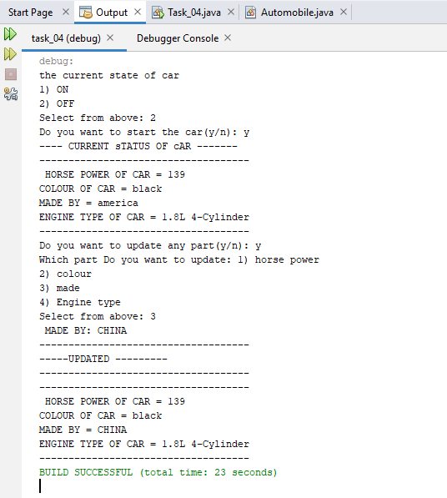

**Task # 05:** Implement a class Car, that has the following characteristics:

a) Brandname

b) PriceNew, which represents the price of the car when it was new

c) Color and

d) Odometer,which is milo meter shows number of milage travelled by car

The class should have:

A. A method getPriceAfterUse() which should return the price of the car after being used according to the following formula: car price after being used=priceNew*(1-(odometer/600,00))

B. A method updateMilage (double travelled distance) that changes the current state of the car by increasing its milage, and

1. A method outputDetails() that will output to the screen all the information of the car, i.e. brandname, priceNew,price used,color and odometer.

**Solution:**

**Main(**

car c = new car();

char res;

Scanner input = new Scanner(System.in);

do {

System.out.println("Please Choose From Below !!");

System.out.println(" 1) Input Car Details \n 2) Display Car Details \n 3) Update Milage \n 4) Price AFter Usage");

System.out.print(" Enter :");

res = input.next().charAt(0);

switch (res) {

case '1': c.insert(); break;

case '2': c.Display(); break;

case '3': c.updateMilage(); c.Display(); break;

case '4':

System.out.print("The Price of the Car After Being Used :");

System.out.println(c.getPriceAfterUse()); break;

default:

System.out.print("-------------Invalid!!!!!-------------\n");

}

System.out.print("Do You Want To Exit Or Not (y / n) : ");

res = input.next().toLowerCase().charAt(0);

} while (res == 'n');

}

**)**

**Class Car(**

Scanner input = new Scanner(System.in);

String name = "AUDI";

String color = "Blue";

Double Odometer = 0.05;

Double pricenew = 50000.00;

void insert() {

System.out.print("Enter Brand Name Of Car : ");

name = input.nextLine();

System.out.print("Enter Colour Of Car : ");

color = input.nextLine();

System.out.print("Enter Odometer Of Car : ");

Odometer = input.nextDouble();

System.out.print("Enter New Price Of Car : ");

pricenew = input.nextDouble();

} void Display() {

System.out.println("-----------------------------------------------------");

System.out.println("Your Name Of Car Is ==> " + name);

System.out.println("Your Colour Of Car Is ==> " + color);

System.out.println("Your Odometer Of Car Is ==> " + Odometer+"km");

System.out.println("Your New Price Of Car Is ==> " + pricenew);

System.out.println("-----------------------------------------------------");

} Double getPriceAfterUse() {

Double AfterUsage;

AfterUsage = (pricenew) * (1 - (Odometer) / 60000);

return AfterUsage;

} void updateMilage() {

double IncreaseMilage;

double distance;

System.out.print("Enter Travelled Distance : ");

distance = input.nextDouble();

IncreaseMilage = distance + (Odometer);

System.out.println("The New Milage OF Car Is ==> : " + IncreaseMilage);

}

**)**

**Output:**

